

**Report on Design Thinking Project**

Subject : Technology and Information Systems (SECP 1513)

Section : 05

Name of Lecturer : Dr Azurah A Samah

Date : 29/11/2023

Title of Design Thinking Product : Student-centric mental health app, HealHub

Video Link (youtube): https://youtu.be/1u6Ve1g8LpA

## Group Profile

|  |  |  |
| --- | --- | --- |
| Name: Austin See Yong Hui  Matric Number: A23CS5015  E-mail: austinseeyong@graduate.utm.my  Phone number: 0167348887  Course: SECJH  E-portfolio link: https://eportfolio.utm.my/user/austin-see-yong-hui/page-template | Name: Muhammad Aidil Haikal bin Mazalan  Matric Number: A23CS5010  E-mail: muhammadaidilhaikal@graduate.utm.my  Phone number: 0196382275  Course: SECJH  E-portfolio link: https://eportfolio.utm.my/user/muhammad-aidil-haikal-bin-maza/technology-information-system | Name: Sioh Ying Yi  Matric Number: A23CS0180  E-mail: sioh@graduate.utm.my  Phone number: 0169033650  Course: SECJH  E-portfolio link: https://eportfolio.utm.my/user/sioh-ying-yi/technology-and-information-systems-secp1513-2 |

Comments by Grader:

Table of Contents

Page number

1. Introduction 1
2. Detail step and descriptions 2
3. Detailed description 3
4. Design thinking assessment 5
5. Design thinking evidence 6
6. Reflection 20
7. The task for each member 21

**1.0 Introduction**

Design thinking is an approach to problem-solving that places emphasis on understanding human requirements, coming up with original ideas, and testing and prototyping solutions repeatedly. Both designers and non-designers employ this systematic method to solve challenging issues. It includes the five design thinking steps of define, ideate, prototype, test, and emphasise. Design thinking places a strong emphasis on taking a human-centered approach and fostering a thorough comprehension of the target audience. It encourages innovation, teamwork, and a readiness to modify and improve solutions in response to ongoing feedback. This approach has been widely used in many industries to solve problems, be creative, and provide solutions that are focused on the needs of the user.

We will go through a step-by-step explanation of HealHub, an app that helps students become more conscious of or improve their mental health, in this report.

The HealHub apps are digital resources with a range of functions that promote mental health, including behaviour control, education, mindfulness training, mood monitoring, access to therapy, and community support. They are not a replacement for expert assistance, but they do provide self-help resources, accessibility, and convenience. Selecting trustworthy apps is important, and keep in mind that getting advice from a mental health professional is essential, particularly for severe or persistent mental health issues.

**2.0 Detail Step and Description**

Empathy

Empathy will be the first stage in design thinking where we are able to come out with a good idea by putting ourselves in others shoes. In this way, we can fulfill the request of targeted respondents efficiently. Firstly, we need to know our target respondents, which are students for ours design thinking product. Throughout this stage, we had done face-to-face interviews with 3 different students from UTM. We asked about their personal information and also if they have any kind of mental health problems or problem in managing their stress.

Define

Define is the following stage where we are going to identify and list out the problems faced by the respondents to ease our progression in the further stage. After interviewing the 3 respondents, we have known the problems faced by them.

Ideate

Ideate is the stage where we brainstorm to come out with as much as possible of solutions in orders to satisfy respondents needs. With the aids of empathy and define stage, we discuss and list out all the possible methods that may be useful or not in solving respondents’ problems.

Prototype

In this prototype stage, we finalize the idea and turns it into our design thinking product. Due to the reason that our product is a mobile application, we had decided to create a prototype using PowerPoint so we can simulate the real experience while using the prototype we created. The PowerPoint prototype includes several features that function just like a mobile application. Hence, the respondents can really use their mobile phone, tablets or laptops to experience the prototype.

Test

At the final stage, it’s the time to test out the prototype with the previous respondents. We showed and explained the features of the mobile applications prototype to the respondents. Furthermore, we asked the users about their experience and feedbacks after using our prototype. This may allow us to make an improvement towards our product.

**3.0 Detailed and description of the project**

Problem

After the interview session with students, we found that the students nowadays are having a lot of pressure. One of the common problems that major students meet is about the academic pressure. The never-ending cycle of homework, assessments, and exams frequently causes students to feel overburdened and they find that it very difficult to manage their time efficiently. Most of the students always express that they have a lot of pressure when there is a lot of assignment supposed to be completed and submitted in strict deadlines. This has affected their mental health and the mood of the students as most of them started to have a low sleeping quality. In addition to coursework and exams, the wide variety of extracurricular activities in university, like club participation, events, and social interactions are also added to students' stress levels. Most of them feel difficult to find a balance between extracurricular and academic obligations. Students are always experiencing emotional exhaustion and from the interview, we know that most of them are having a negative emotional included stress, anxiety and a sense of loneliness. They fell hard to control their emotion as they have nowhere to relive stress and they do not have any mental support. They started to lack of self-motivation and they felling tedious in doing their work.

Solution

By knowing this, our group decided to foster a good mental health among students. Thus, we decided to come with a user-friendly application which known as “Heal Hub” that provide constant support and assistance to student so that students can manage their mental health in a good way. During the moments of distress, students may fell hard and struggle to find an immediate support or resources. "Heal Hub" has provided a real-time chat feature which could allow the users to have immediate access to licensed professionals so that they can seek support from them. The 24/7 online virtual support is available at all the time. Thus, the users can chat with our counsellors at any time they need. The users are also allowed to start a video call with our counsellor so that the users and the counsellor can have a better understanding with each other. Not only that, it’s much easier for the counsellors to pick up on body language and subtle signals that can convey a world of meaning when they starting a video call. So, even if the users don’t have the words to express their thoughts, face-to-face counselling enables further discussion of the issues affecting them. A face-to-face therapy can also make the users feeling secure enough to share their personal details. If users feel more comfortable to chat with peer, we can also enable them to meet with our experience peer and shared their story with them. Not only that, “Heal Hub” provide a quick personality assessment for users. This can help them to test the status of their mental health and stress level so that the users can identified their condition earlier before it become worsen. If the user is being identified to have a mental health problem, they can have a quick access to our online virtual support and get an early treatment. “Heal Hub” also provide a self-heal resource to relax out mind when we rest. Lastly, we also provide an anonymous chat. It will provide a chatbot where students can share their thought anonymously with verified group admins to prevent unhealthy conversation.

Team working

In the aspect of teamworking, our group has split ourselves into different tasks. Austin and Ying Yi will mainly focus on interview the respondents and content of report while Aidil will focus on explaining our prototype to the respondents and video production. Three of us do the prototype together to show the creativeness and cooperation of our group members. There are a lot of resistance we faced when conducting this assignment. Firstly, our group members are all busy in other assignment and activities after class. Thus, we are very hard to find a suitable time for group meeting. Luckily, all of us are clear with the task given and we manage to discuss about the project using a shorter time. Besides, we found that it is hard to take a good video because the background sound is quite loud and it will affect the quality of video. So, we need to find a place of interview to minimise the background sound.

**4.0 Design thinking assessment**

During the end of the project demonstration

At the end of the project, we learn that design thinking is a process that is very challenging and need to be done in detail. Design thinking is a problem-solving process that we need to understand people's needs, being creative, and trying out various ideas. It is most likely a loop where we need to keep improving our solution based on users’ feedback. The key is to always listen to the people who will use what you are designing. The process of creating a new application is not just technical development but also involves a comprehensive understanding of the market, user behaviour, and the competitive landscape.

During the transition between design thinking phases

At the early state of design thinking, we have faced some problems. Firstly, we notice that it is difficult for us to find a suitable time to discuss our project due to busyness in our studies. Besides, we also need to make some adjustments in our prototype to fulfill the demand of our users after each time of interview. Fortunately, our group members have a strong communication and collaboration during discussion. The responsibilities of each member are clearly defined and also the information flowed effectively between the team members. The ability of us in addressing challenges has causes our project conduct successfully.

**5.0 Design Thinking Evidence**

**Sample work**

Diagram 1: Interview respondents 1

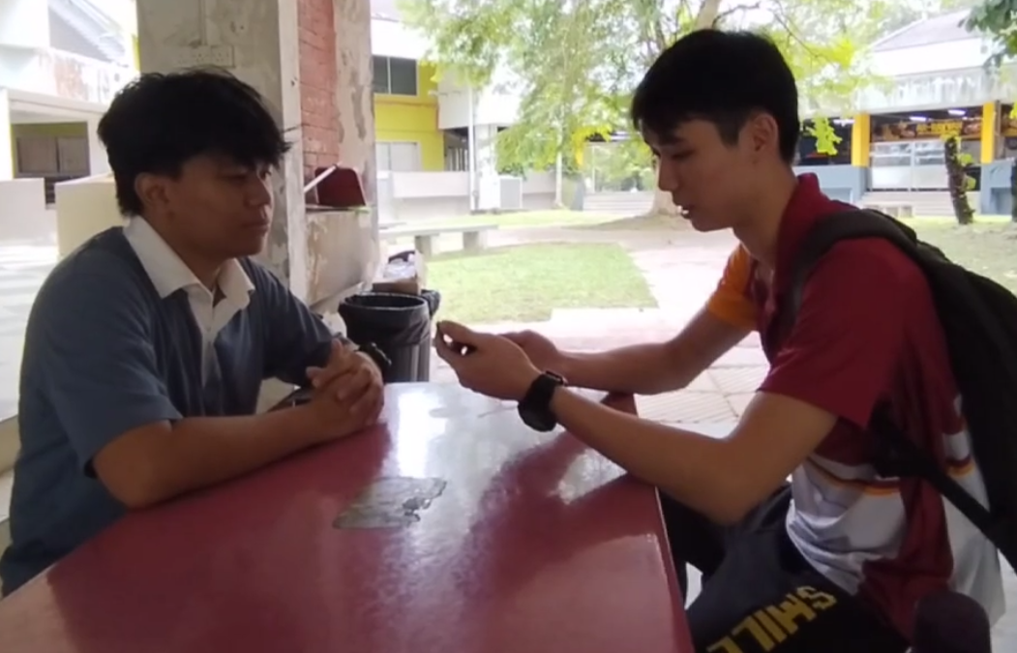

Diagram 2: Interview respondents 2

Diagram 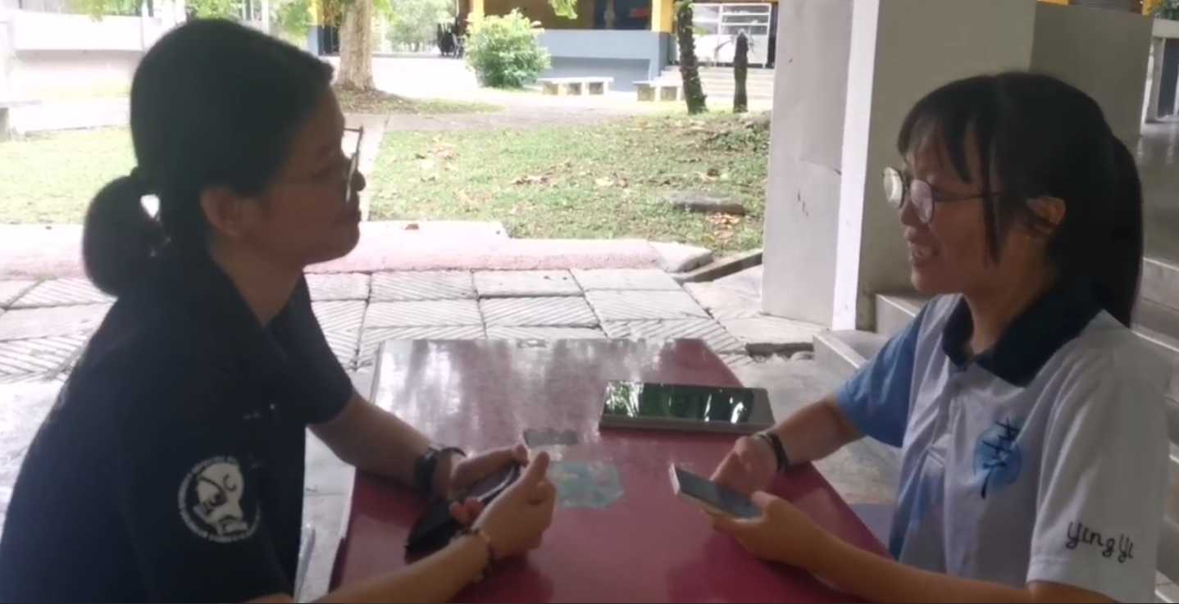3: Interview respondents 3

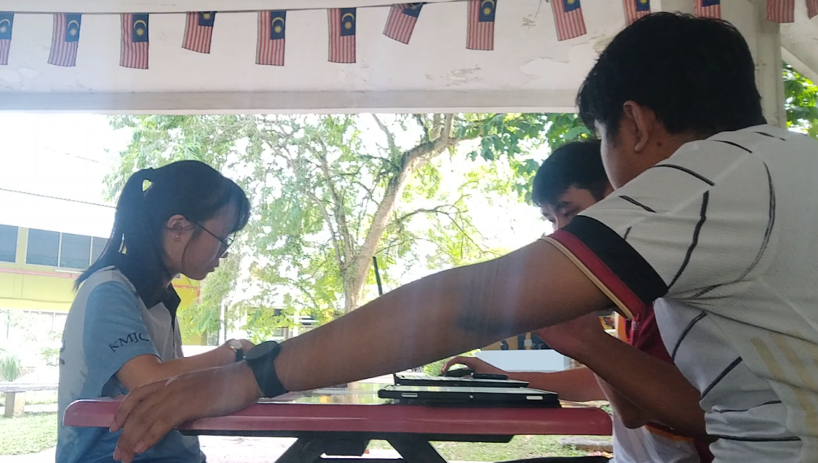

Diagram 4: Stage define and stage ideates

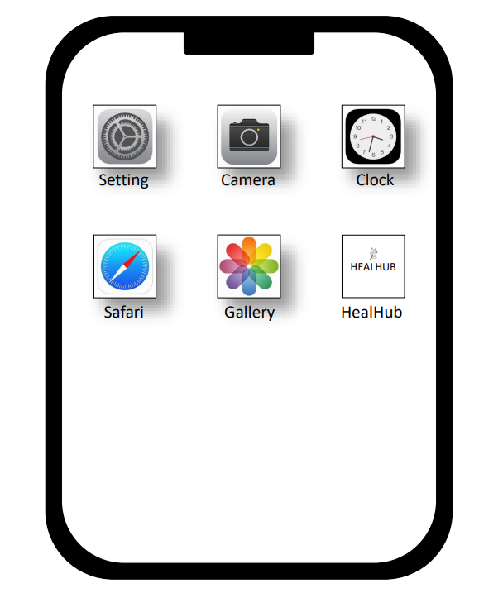

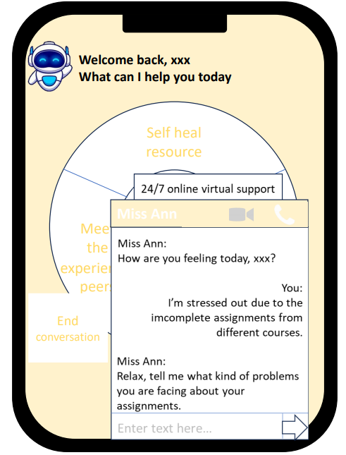

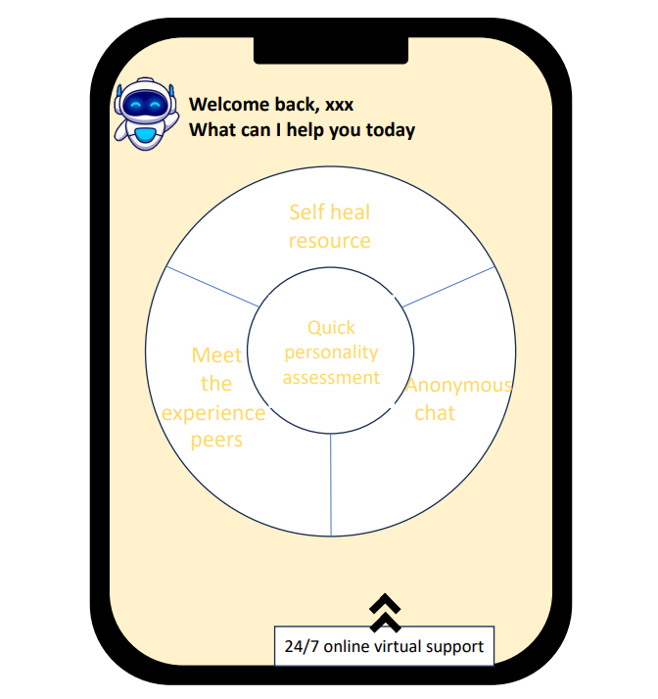

Diagram 5: Pages of prototype

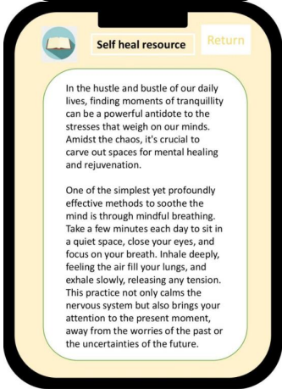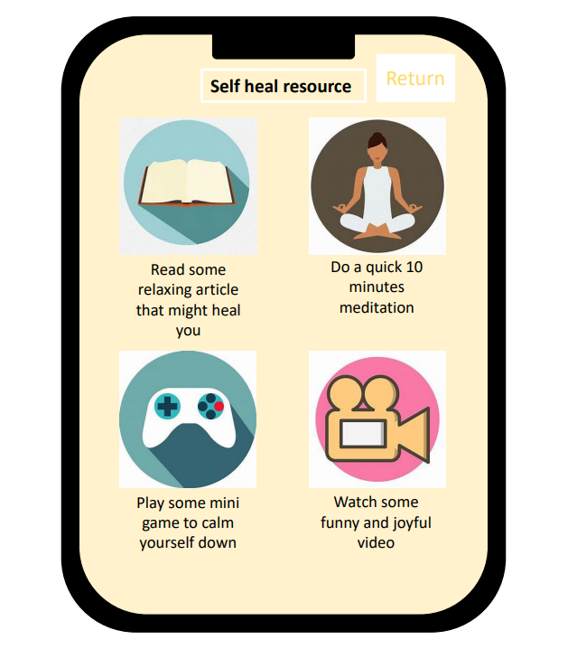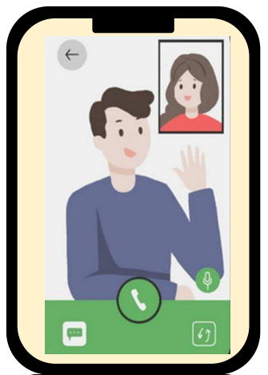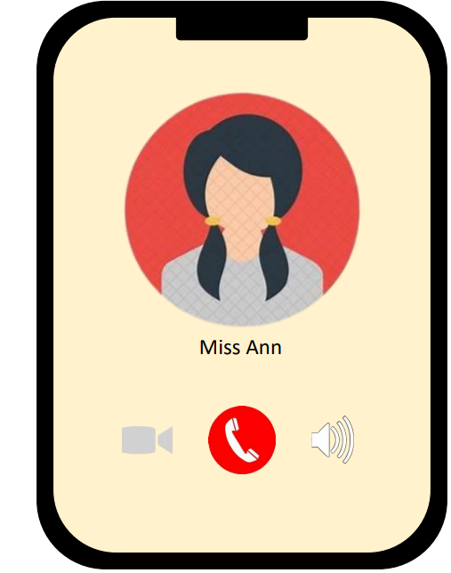

Diagram 6: Pages of prototype

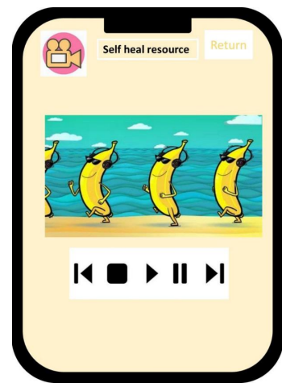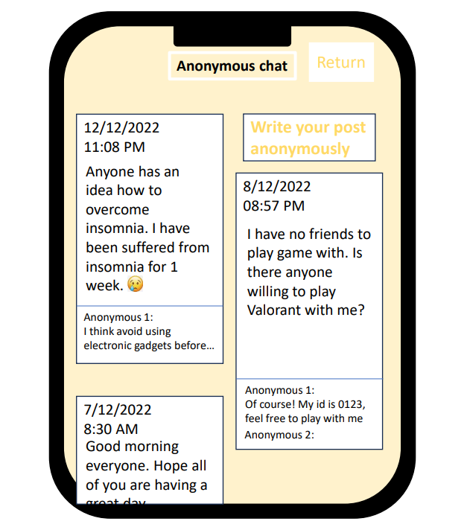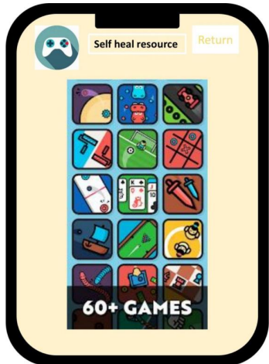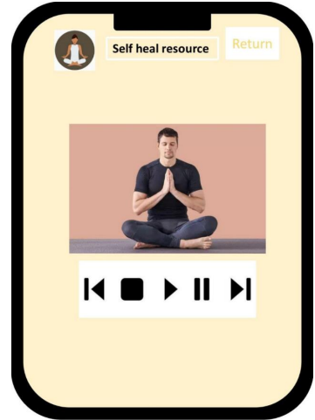

Diagram 7: Pages of prototype

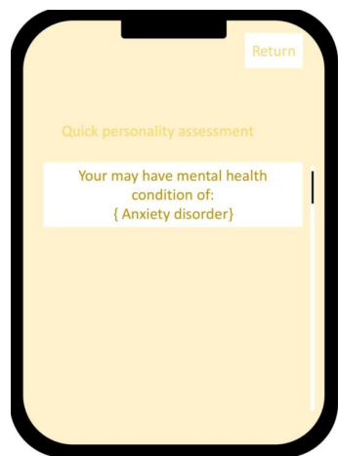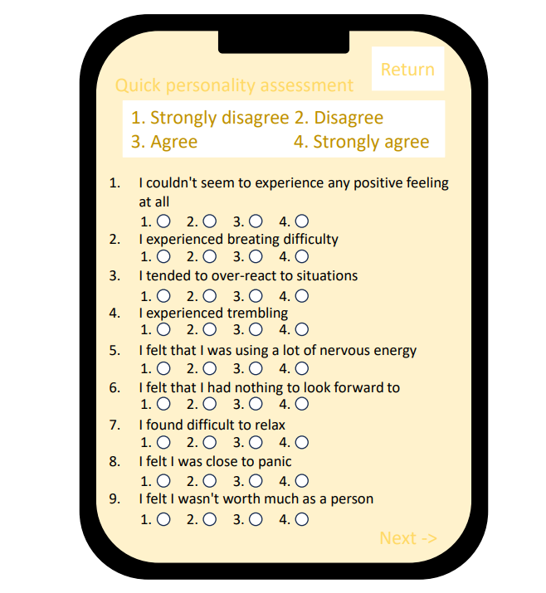

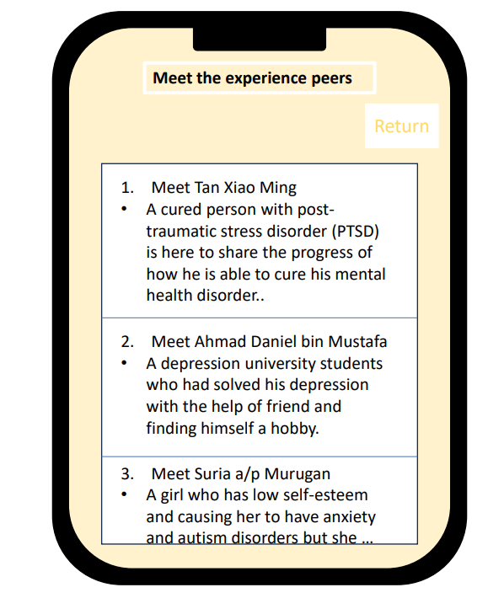

Diagram 8: Pages of prototype

Diagram 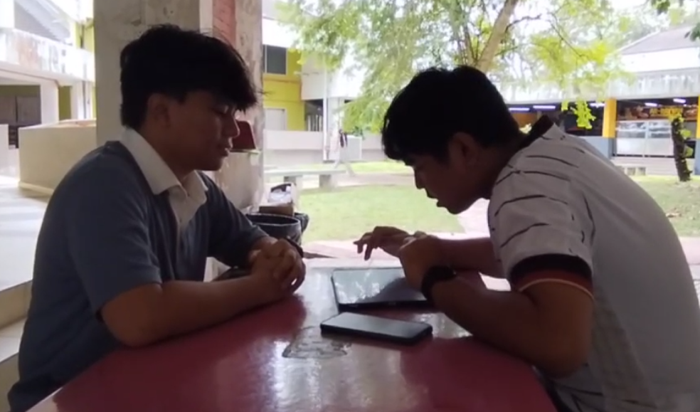9: Prototype testing with respondents 1

Diagram 10: Prototype testing with respondents 2

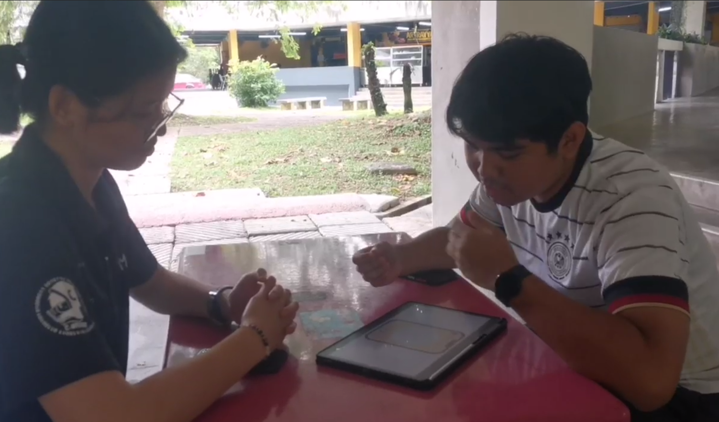

Diagram 11: Prototype testing with respondents 3

**Record for each phase**

Stage empathy

Respondents 1

|  |  |
| --- | --- |
| Question | Answer |
| What is your name? | Faiz |
| What is your age? | 19 |
| Are you a student? | Yes |
| Do u have any mental health problem or always feel stress? | Sometimes, usually when there are a lot of assignments. |
| What will you do when u feel stress? | Nothing to do. |
| Do you have any mobile app that help you to tackle your mental health problem or relieve stress? | No, I used to play mobile game but now the time when I play games is getting shorter. |
| What is provided in the mobile app which help you to relieve stress? | N/A |
| What do you think should be included in an app to help students in overcoming their mental health problem? | Something that can help user in time management or making time table. |

Table 1: Q&A respondents 1

Respondents 2

|  |  |
| --- | --- |
| Question | Answer |
| What is your name? | Iskandar |
| What is your age? | 20 |
| Are you a student? | Yes |
| Do u have any mental health problem or always feel stress? | Sometimes I felt stressed out with certain issues and have the difficulties to express. |
| What will you do when u feel stress? | I will distract myself by doing my hobbies. |
| Do you have any mobile app that help you to tackle your mental health problem or relieve stress? | Currently no. |
| What is provided in the mobile app which help you to relieve stress? | N/A |
| What do you think should be included in an app to help students in overcoming their mental health problem? | An app that are user friendly and the users can express their feeling through the app. |

Table 2: Q&A respondents 2

Respondents 3

|  |  |
| --- | --- |
| Question | Answer |
| What is your name? | Chen Shu Yan |
| What is your age? | 19 |
| Are you a student? | Ya. |
| Do u have any mental health problem or always feel stress? | I do not have a mental health problem but sometimes I feel stress handling the extra-curriculum activities. |
| What will you do when u feel stress? | I will play volleyball. Carry out some sport activities. |
| Do you have any mobile app that help you to tackle your mental health problem or relieve stress? | No, I do not rely on any mobile app. |
| What is provided in the mobile app which help you to relieve stress? | N/A |
| What do you think should be included in an app to help students in overcoming their mental health problem? | The app can include a music listening features. |

Table 3: Q&A respondents 3

Stage Define

|  |  |  |  |  |
| --- | --- | --- | --- | --- |
| Respondents | Problems | | | |
| Respondent 1 | Do not have an appropriate mobile application that help to cure mental health or relieve stress | Feeling stress when there are a lot of assignments to deal with | X | X |
| Respondent 2 | X | Do not have a good way to relax while stress |
| Respondent 3 | X | Stress when there is a lot of tasks from extra-curriculum | X |

Table 4: List of Problems from the respondents

Stage ideates

|  |  |
| --- | --- |
| Process | Ideate |
| Before | 1. Discuss to come out with the ideas of design thinking product. 2. Listing as many problems and solutions to determine our final decision about design thinking product. 3. Choose the topic of student-centric mental health app among several choices of gamified learning platform and collaborative digital note-taking platform |
| Intermediate | 1. List out all the features should be included in the student-centric mental health app which are :  * Personalized Assessment * Self-Help Resources * 24/7 Virtual Support * Experience peer Support * Anonymous chat  1. Deciding the process of making prototype either in paper-prototype or in PowerPoint. |
| After | 1. Deciding to make an improvement against the prototype after taking feedback from the respondents. The improvements include:  * Adding music listening feature * Adding feature that would help in time management * Adding feature where the users can get more information about their mental health condition after using the personal assessment. |

Table 5: Lists of ideas

Stage prototype

|  |  |
| --- | --- |
| Features | Function |
| Self-heal resource | This feature allows the users to do some relaxing and users friendly activities including reading articles, meditation with guides, playing mini games and also watching video. |
| Anonymous chat | This feature allows the users to express or share their feeling anonymously. Others users from the app are able to see it and give help by giving them some useful suggestion, console or motivation. The feature will also filter out and delete the unhealthy posts and replies. |
| Quick personality assessment | By using this feature, the users are able to know their current mental health condition. They can know if they are currently suffered from mental health problems such as having depression, anxiety or ADHD. So, they can proceed to the next step to cure their mental health disorders. |
| Experience peers support | This feature allows the users to read the article wrote by the cured mental health disorder patients. In this feature, the peer with previous experience in mental health problems can share the methods how they are able to overcome with the mental health problems. |
| 24/7 online virtual support | This feature allows the users to get virtual support online at any time. The users can have a quick conversation either in chat or in voice call with an experienced advisor or counsellor to solve their current problems. |

Table 6: Function of each feature

Stage test

|  |  |
| --- | --- |
| Respondents | Feedbacks |
| Respondents 1 | The prototype is good since it is included with the anonymous chat so the users can share their feeling with anyone. There is also included features which teach meditating. |
| Respondents 2 | The prototype created can be said a better app than the app I had used before. And I will really use it if I need so. |
| Respondents 3 | For the feature of personal assessment, it will be better if there is added another feature where the users can get information to cure their mental health disorders. |

Table 7: Feedbacks from the respondents

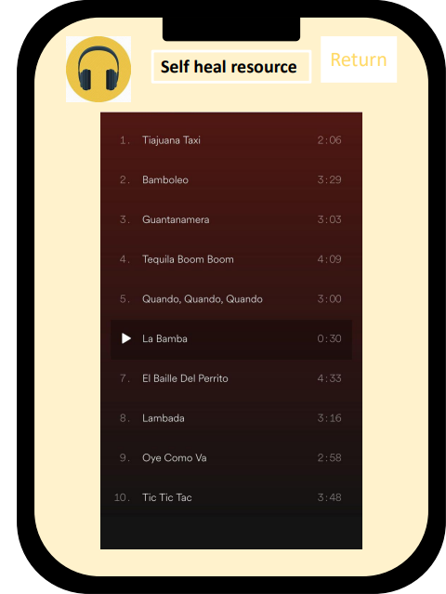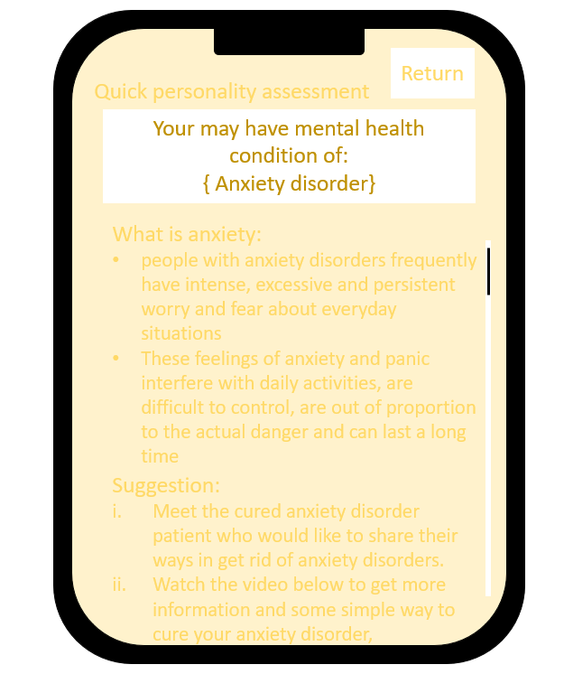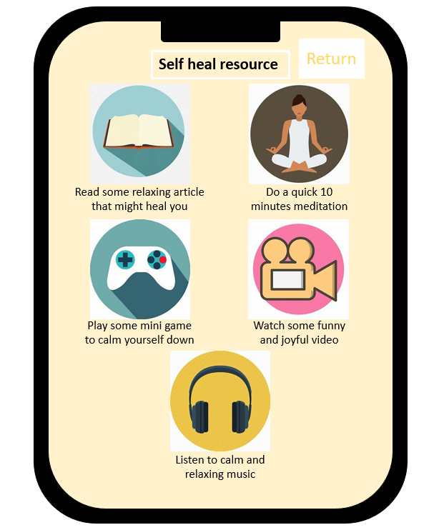

Diagram 12: Modified prototype pages

**6.0 Reflection**

1. My goal is to become a skilled and innovative software designer in future. I hope I can create a useful and reliable software application that can address real-world problems and contribute to the industry. Design thinking has significantly impacted my goal by enhancing my soft skills. For example, communication skill, creativity, and cooperation. These skills are important for me because I can instill these to my daily lifestyle and help me to contribute in the future. By now, I will start to invest time in developing my technical skills through hands-on projects, workshops, and continuous learning to achieve my goal.
2. After finishing the design thinking project, I am sure that creating a new software that fit to every user need is difficult. Everyone should work together in their own parts, discussing and making a lot of improvements in order to build up an ideal product. Hence, it is not always to take the most difficult or simplest parts in a project but the part that suit to our abilities.
3. My hope for this course is to learn a lots of new technology and also gain some new knowledge about new trend in Information technology world. I also want to enhance my skills to develop something new to help people or ease them on their dailylife. From this idea thinking project I have learn to produce new thing or already exist but more feature than before . I hope I can get new skill that I can relate to real industry worlds. From now on , I will spend my time to develop my skill for idea thinking as an investment for a long time period in the future .

**7.0 The task for each member**

|  |  |  |  |
| --- | --- | --- | --- |
| Name  Tasks | Austin See Yong Hui | Muhammad Aidil Haikal bin Mazalan | Sioh Ying Yi |
| Introduction |  | Writing of introduction in the report |  |
| Detail step and description | Writing of detail step and description in the report |  |  |
| Detailed descriptions include problem, solution and team working |  |  | Writing of detailed descriptions include problem, solution and team working in the report |
| Design thinking assessment points |  |  | Writing of design thinking assessment points in the report |
| Design thinking evidence | Writing of design thinking evidence in the report | Video making, editing | Video recording during interview section |
| Group discussion for define and ideate stages | | |
| Creating prototype | Testing prototype with respondents |  |
| Interviewing respondents |  | Interviewing respondents |
| Reflections | Writing of reflections in the report | | |

Table 8: Task for each member